**Step I:** Create a new MPLAB X project.

**Step II:** Copy into *FreeRTOSConfig.h*, *config_bits.h*, *CerebotMX7cK.h*, and *CerebotMX7cK.c* files into the project directory.

**Step III:** Add *FreeRTOSConfig.h , config_bits.h* and *CerebotMX7cK.h*to the project Header Files

**Step IV:** Add *CerebotMX7cK.c* to the project Source Files.

**Step V:** Create a new logical folder under Source Files – *FreeRTOS*.

**Step VI:** Add all C files in the ***Source*** directory.

**Step VII:** Add *heap_2.c* from the ***Source/MemMang*** directory. (*croutine.c, list.c, queue.c, task.c, and timers.c*)

**Step VIII:** Add *port.c* and *port_asm.asm* from the ***Source/MPLAB/PIC32*** directory.

**Step IX:** Create a new file called main.c under Source Files. If required, create a new file called main.h under Headers Files.

**Step X:** Verify that the project window appears as shown in the figure below.

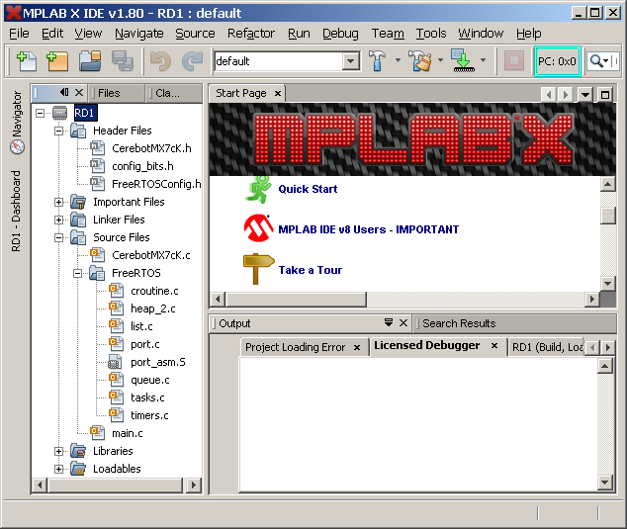

Figure 1. FreeRTOS directory structure

**Step XI:** Highlightthe project Name as shown in . Right click the mouse button and select Properties from the bottom of the drop down list. This will result in displaying the project options as shown in Figure 2 based on the selections made during the creation of the project.

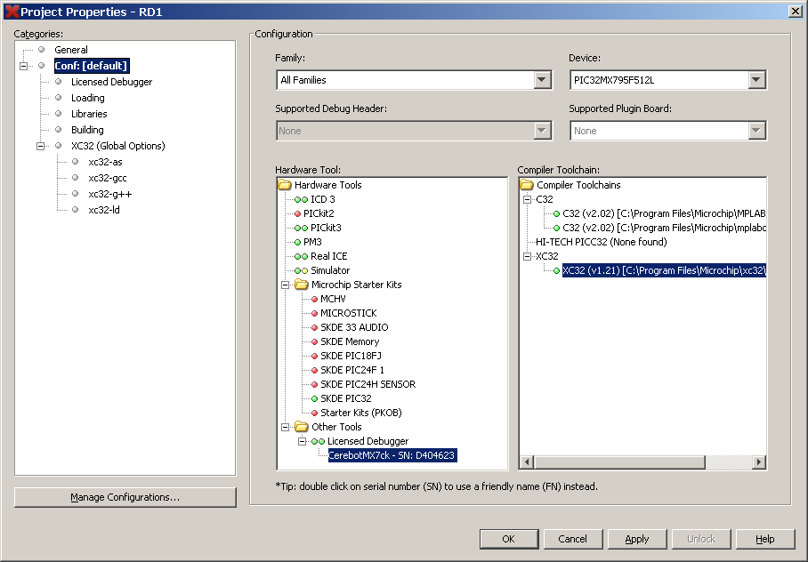

Figure 2. Project Properties window.

**Step XII:** The following steps modify the project Make File for the XC32 assembler.

**Step XII a:** Click on the bulleted item labeled xc32-as. A window as shown in Figure 3 is now displayed.

**Step XII b.** Click on the […] box beside the line Preprocessor Include directories. Enter the text as shown in Figure 4.

**Step XII c.** Click on the […] box beside the line Assembler Include directories. Enter the text as shown in Figure 5.

**Step XII d.** Add the text for the entry box for **Advanced options:** *-gdwarf-2*

**Step XII e.** Click on the box labeled Generate Command Line. The text in the display window should read: *--gdwarf-2 -I"../../common/include" -I"../../../Source/include" -I"../../../Source/portable/mplab/pic32mx" -I".." -I"../../../Source/portable/mplab/pic32mx",-I"..* as shown in .

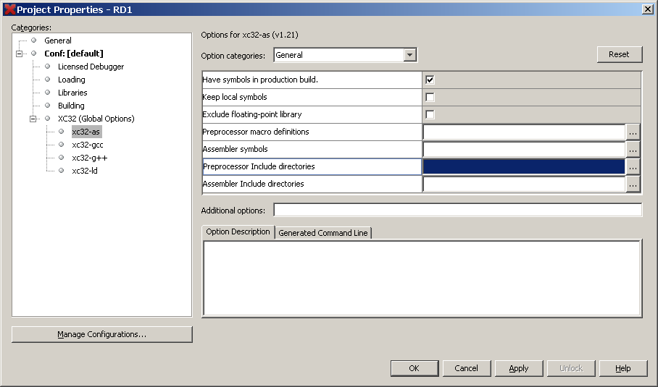

Figure 3. Project Properties XC32-as configuration window

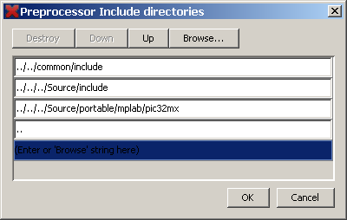

Figure 4. Assembler preprocessor include directory window

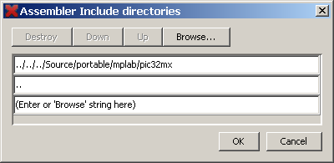

Figure 5. Assembler include directory window

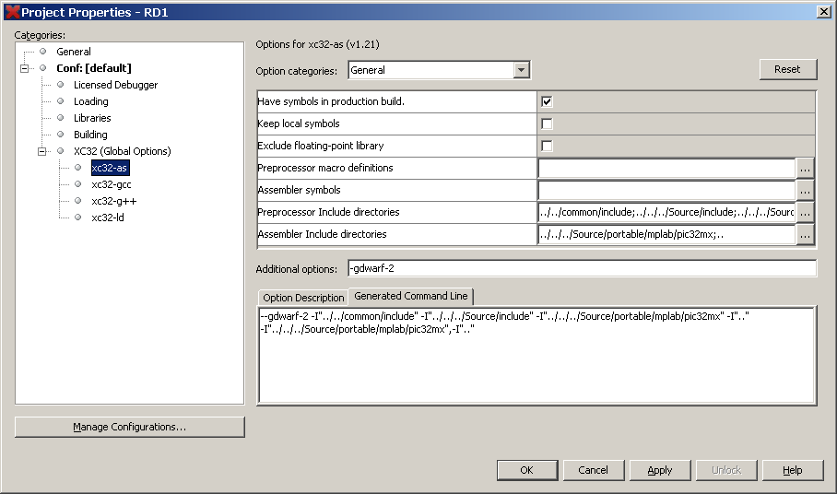

Figure 6. Completed Project Properties window for xc32-as after configuration

**Step XIII:** The following steps modify the project Make File for the XC32 C compiler.

**Step XIII a:** Click on the bulleted item labeled xc32-gcc shown in Figure 2. The window shown in Figure 7 will now be displayed.

**Step XII c.** Click on the […] box beside the line Include directories. Enter the text as shown in Figure 8.

**Step XII d.** After completing the Include directories window, click on Generated Command Line. The text in the display box should read: *-g -I"../../common/include" -I"../../../source/include" -I"../../../source/portable/mplab/pic32mx" -I".."* as shown in Figure 9.

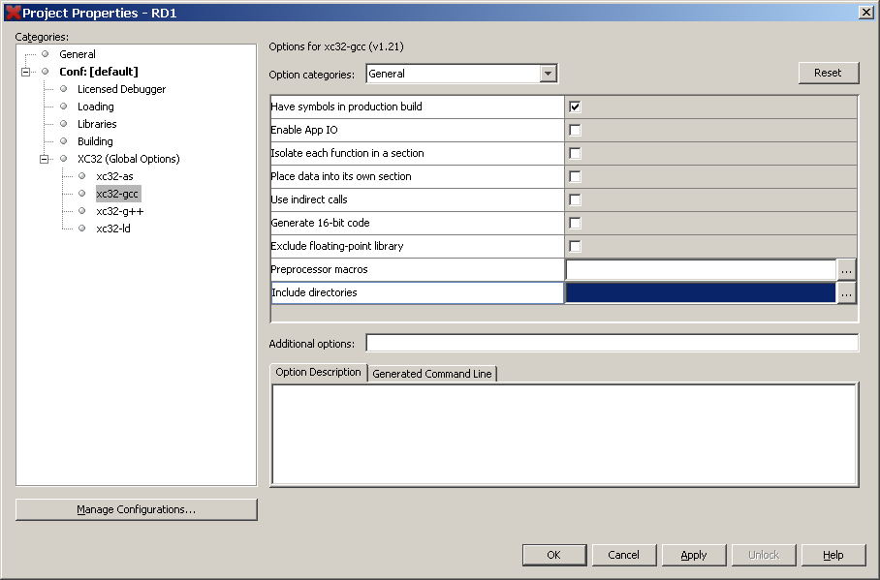

Figure 7. Project Properties XC32-gcc configuration window

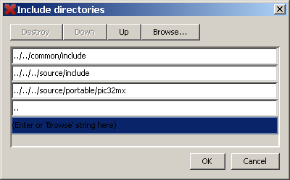

Figure 8. C compiler include directory window

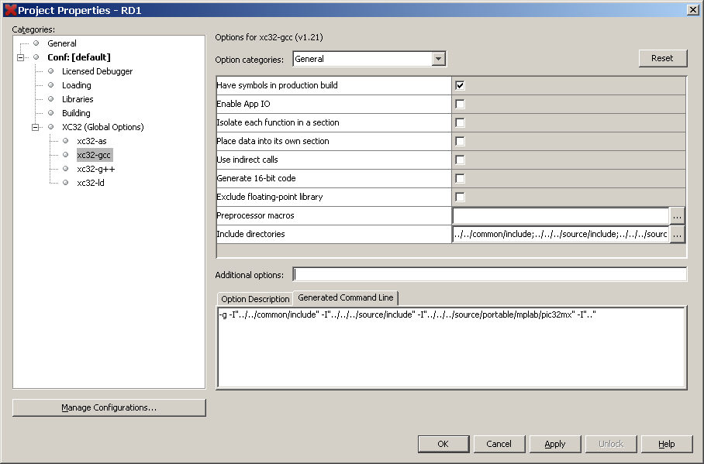

Figure 9. Completed Project Properties window for xc32-as after configuration